Note

The coding portion of this lesson is much more difficult than that of the last, so this explanation will be more thorough.
Step 1  In order to complete the lesson, students need to understand the concept of a variable.  Look in the Variable section of Scratch, and click ‘Make a Variable’. | 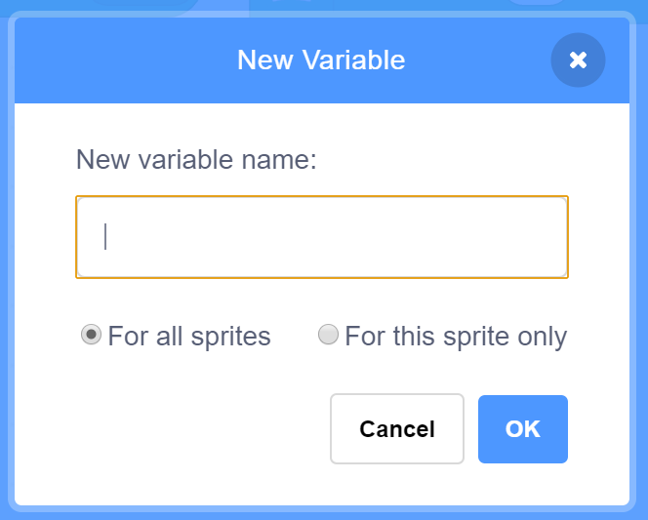
Step 2  You’ll see your variable appear on the screen next to your code.  Find the new variable blocks in the Data section.  Write this code to create a variable and set its value to 300. This will be the threshold for the distance sensor. | 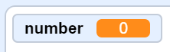  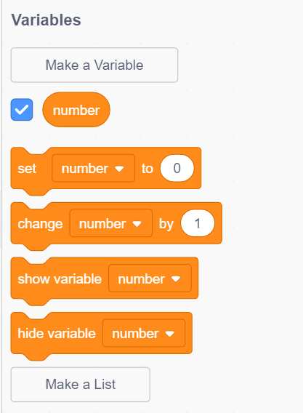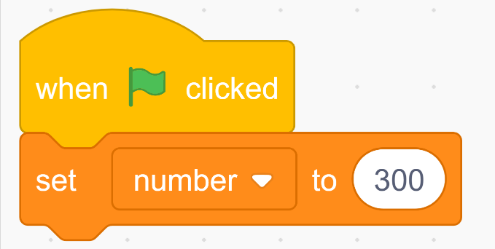
Step 3  Like one version of the code in the last lesson, this one will require the Forever loop.  Inside there will be two Repeat Until loops. These loops will constantly be checking if one of two conditions have been met. The conditions are:  - The car’s sensor has sensed an obstacle 300 units (or less) away  - The car’s sensor has NOT sensed an obstacle 300 units (or less) away | 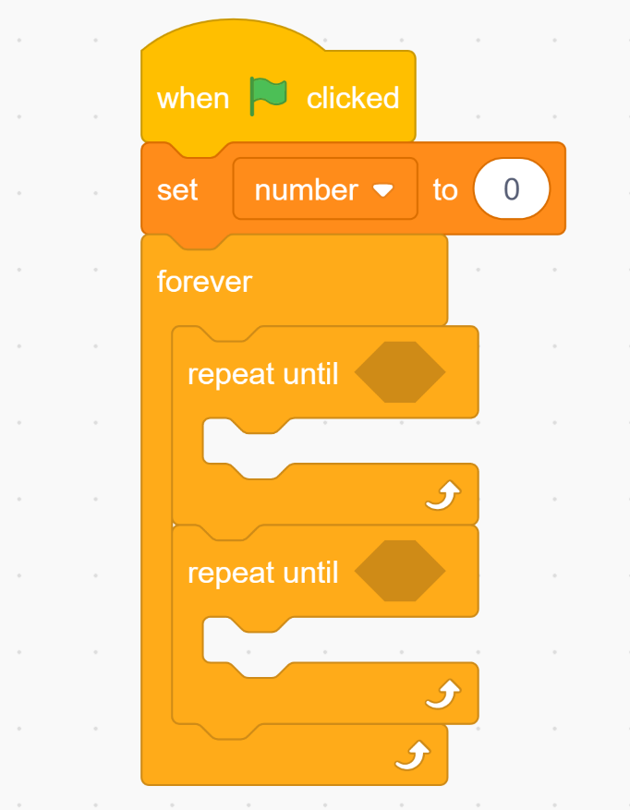
Step 4  The car’s sensor has sensed an obstacle 300 units (or less) away  The car’s sensor has NOT sensed an obstacle 300 units (or less) away  Translating these two conditions into code can be difficult for beginners:  One helpful method is to walk through the code using words, like this  “When the IR sensor doesn’t see an obstacle 300 units (or less) away, it drives forward at speed 500 ”  Remember: The IR sensor measures proximity, so a larger value for the IR Sensor means the obstacle is further away. | 