Note

There are two ways to solve the problem,
1. Using an If statement wrapped in a forever loop
2. With a key pressed event

These instructions will show both solutions.
Step 1  To move forward, use the Go block and set the speed to 500.  Setting the speed to a negative number will cause the car to drive backwards.  TIP: Right click on a set of blocks and choose “duplicate” to copy that piece of code. | 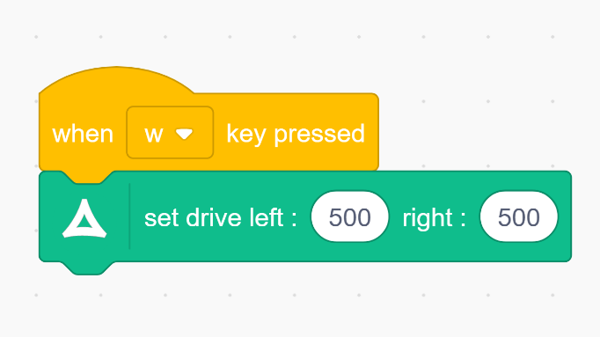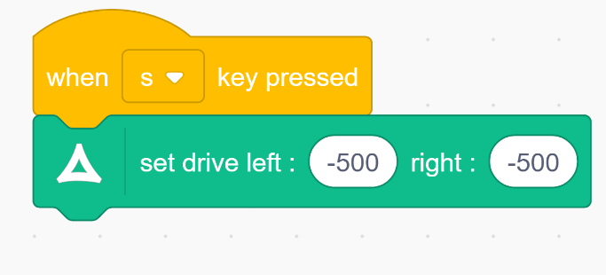
Step 2  In order to turn left of right, you need to preface your Go block with a Steering block so the wheels will turn before the car starts to move. | 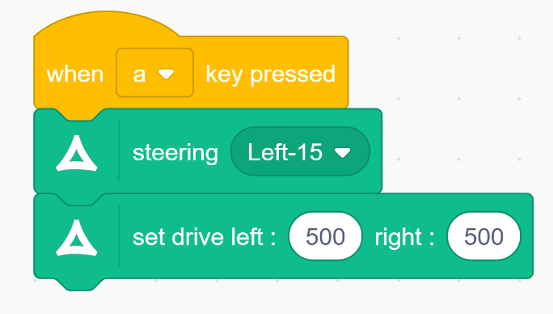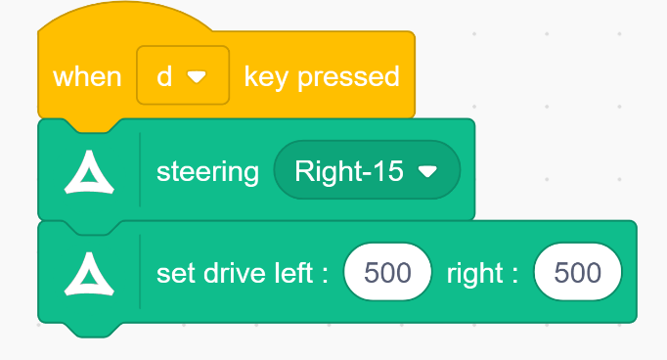
Step 3  Common problem:  Once you run the code to turn the car, you will find that your forward and backward code no longer work correctly. This is because the steering values do not reset back to 0 after the the car turns.  To solve this problem edit the code like this: | 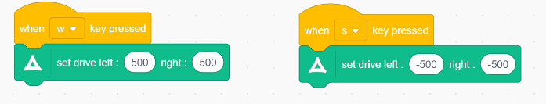
Step 4  Here is the answer to Step 1 coded using the other method. | 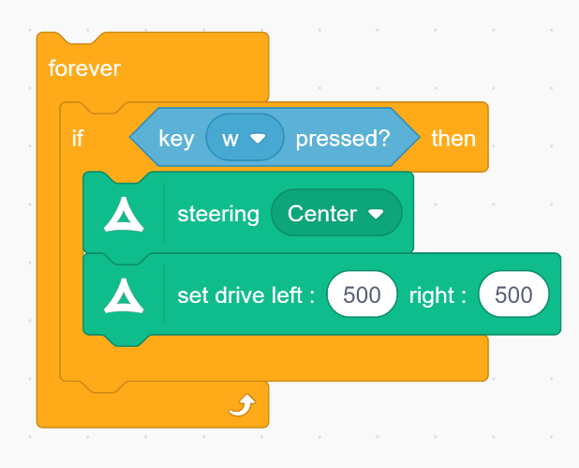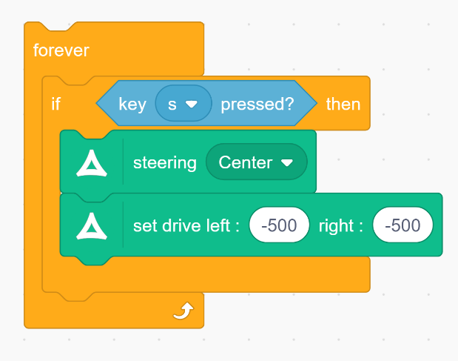
Step 5  Here is the answer to Step 1 coded using the other method. | 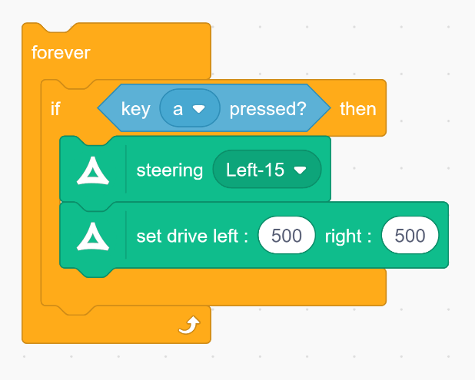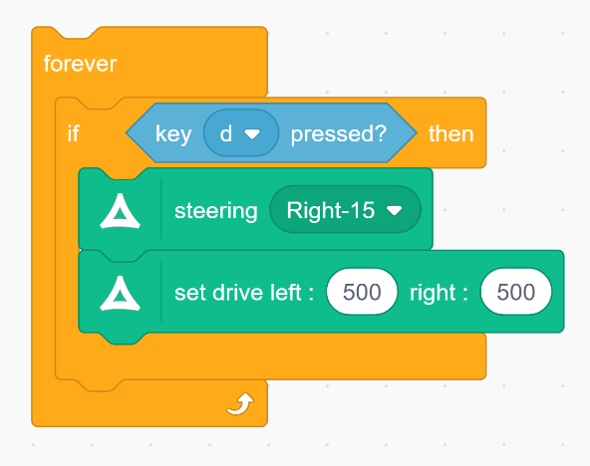
Step 6  To make your code more usable, try adding some code to make the car stop.  To stop moving, use a Go block and set the speed to 0. | 